NAME :-ANANT HON

2124UMLM2029

4)Create a Table with Constraints

a) Create an EmployeeDetails table with EmployeeID as the PRIMARY KEY and DepartmentID as a FOREIGN KEY referencing a Department table. 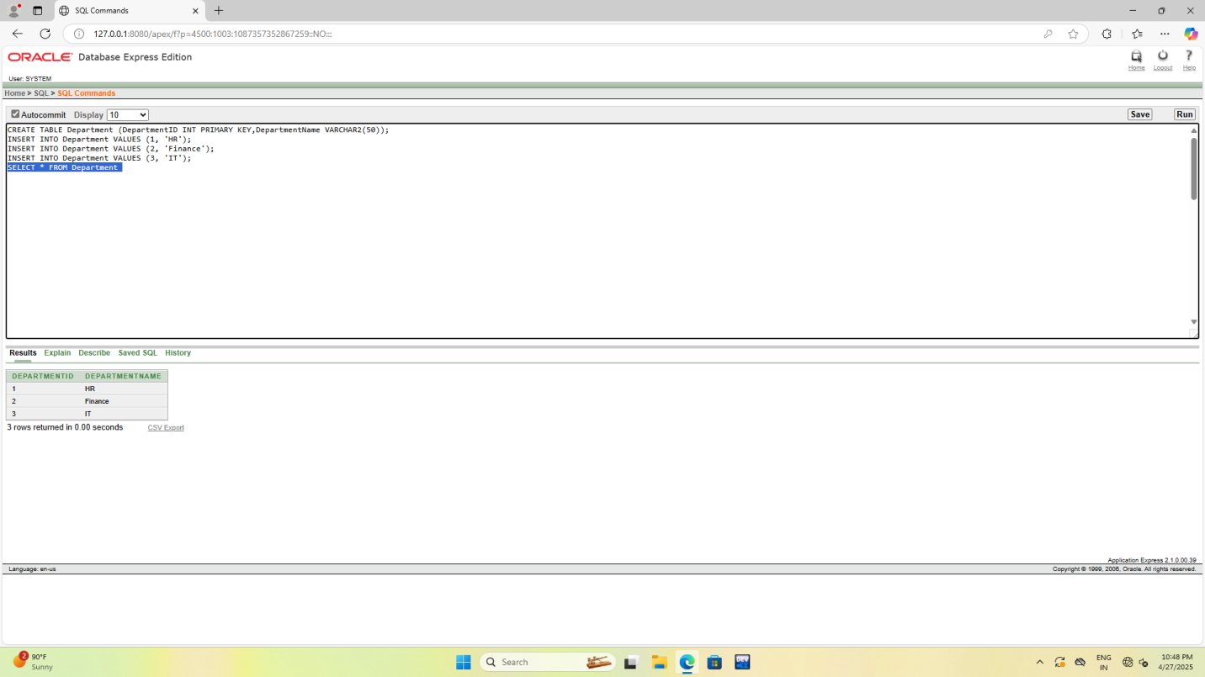

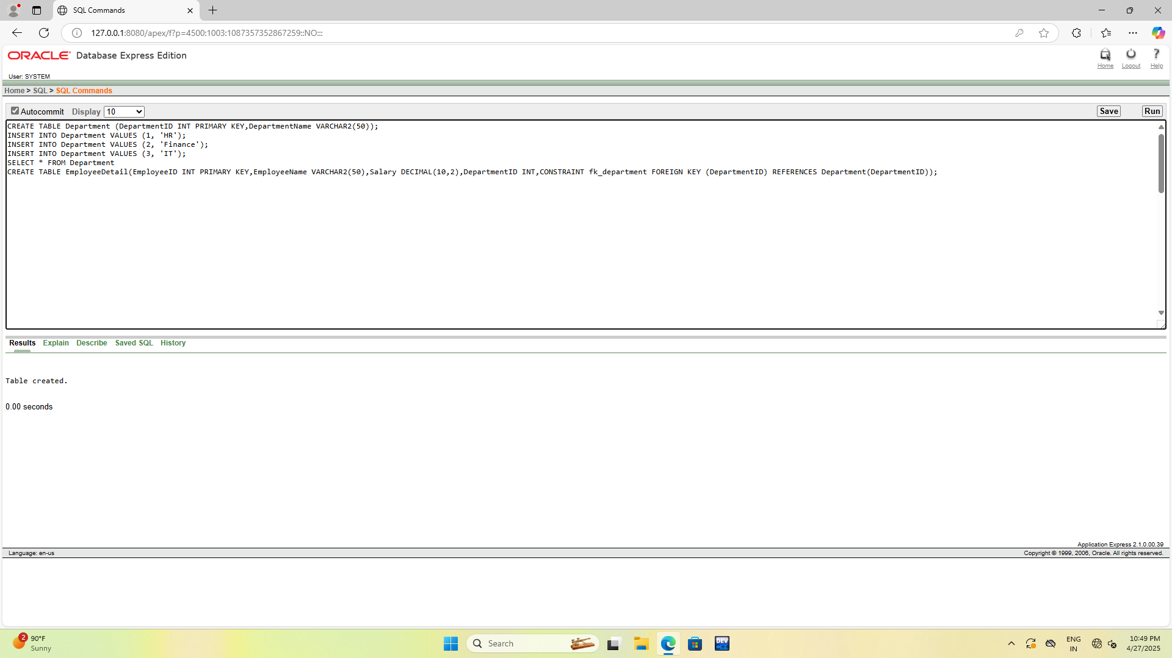

b) Insert a valid employee record with an existing DepartmentID, then attempt to insert an employee with a non-existent DepartmentID and observe the constraint violation.

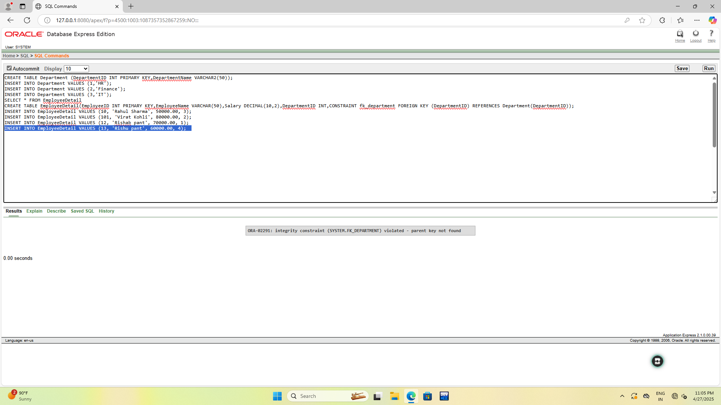

c) Insert an employee with a duplicate EmployeeID and check how the primary key constraint prevents duplicate entries. 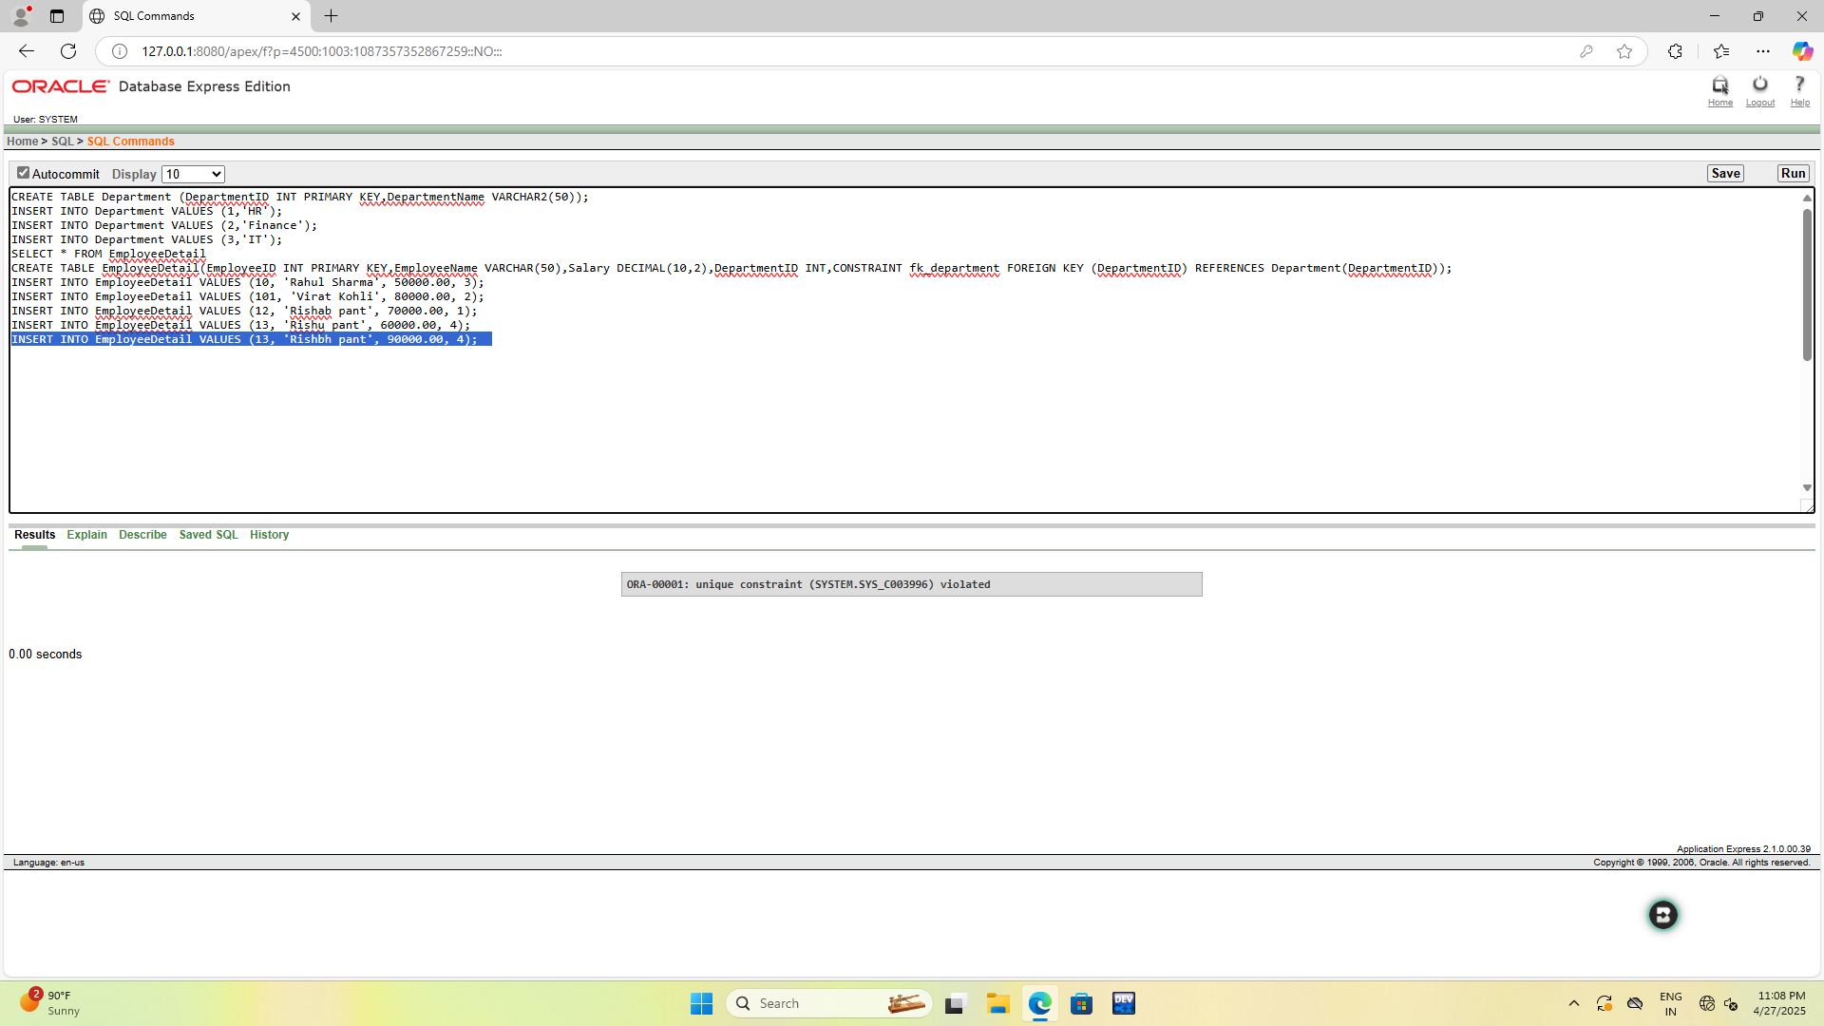

d) Modify the Salary column to have a UNIQUE constraint and attempt to insert two employees with the same salary to test the constraint. 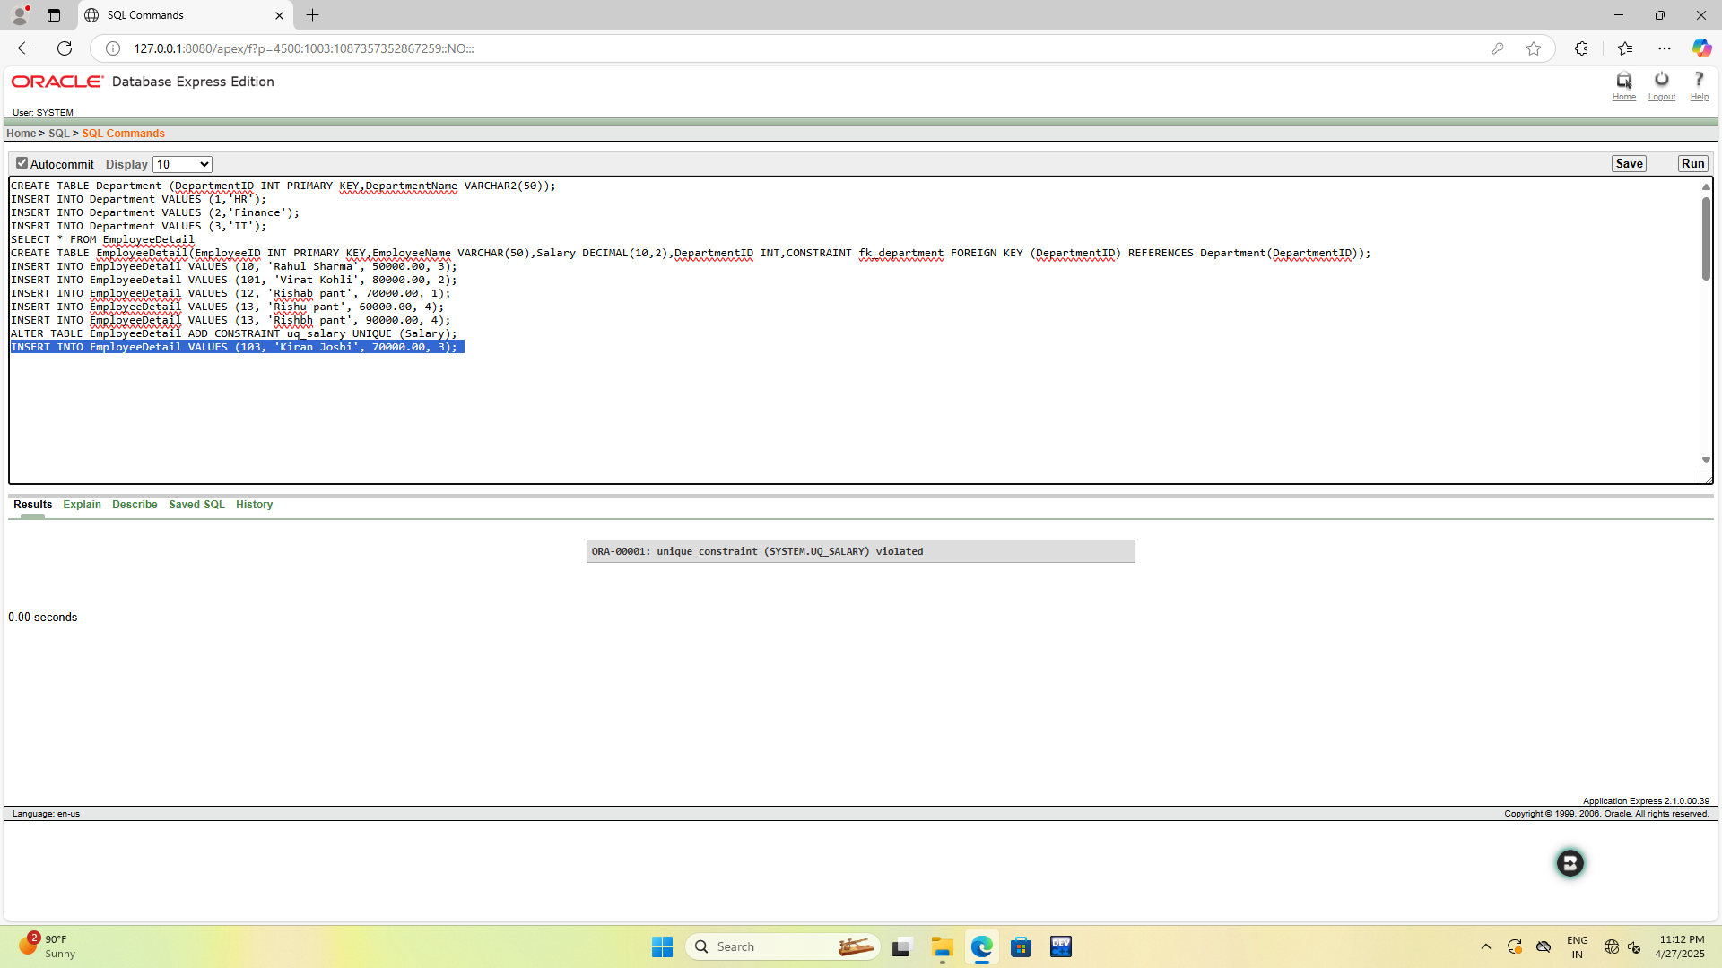

e) Write a query to delete an employee from EmployeeDetails and ensure that the deletion does not violate any referential integrity constraints.